Keith Alcock
4 Apr. 2006

Bicycle Lesson Plan
for Cragin Fifth Grade Class

Subject(s): Math, physical education, science

Grade of children: Fifth

Lesson goal (real world relevance): To learn how to “drive” a bike. Students will learn how the drive train (gears and wheel) of a bicycle works from a mathematical perspective.

Lesson (performance) objectives: Students should be able to
1. explain why one bike goes “farther” than another,
2. understand the equation for distance traveled per pedal turn,
3. calculate the distance for different gears and tire sizes,
4. explain how changes in front and back gears and wheel size affect distance,
5. compute the number of gear combinations a bike has,
6. say how to switch gears to change distance.

Materials needed:
1. A multi-geared bicycle to show students how it works and give them a feel for the forces involved.
2. A trainer to hold the bike stable and provide resistance.
3. New bicycle worksheets (attached)
4. Bicycle race worksheets (attached)
5. Tape measure and string to measure or verify distances

Anticipatory set (introduction): The students have recently visited a museum where they pedaled a bicycle and they probably have bikes at home. They’ve also been working with ratios, perimeters, rounding, multiplication, division, combinations, circles, and rotation, which provide the tools needed to calculate distance and draw conclusions about driving a bicycle.

Procedure:
1. Set up the bike. Explain that we’re going to learn to drive it.
2. Remind them where they recently drove a bike.
3. Figure out which bicycle parts were involved in driving the bike.
4. Think about how a turn of the pedals is translated into distance.
5. Derive an equation for the distance traveled by the bicycle for each turn of the pedals.
6. Use data from the bike to predict distance and then verify it with a measuring tape.
7. Think together about how the parts might be changed, how that would affect the distance, and whether the equation matches. Verify by changing gears and measuring.
8. Use the equation to answer the questions on the new bicycle worksheet together.
[Jump to the evaluation if time is running short.]
9. Work on the bicycle race worksheet in groups.
10. Have each group leader tally and compare them to the teacher’s calculations.
11. Write down distances for each brother for their favorite gears and ask who fill go farther. Find out from the other groups which back gear would be required to get farther than Andrew. Use the table below.

Rider | Favorite front gear | Back gear | Gear ratio | Wheel circumference | Distance
Andrew¹ | 52 | 18 | 2.9 | 63 | 180
Brad | 38 | 24 | 1.6 | 82 | 130
Dean | 30 | 16 | 1.9 | 85 | 160
Brad² | 38 | 16 | 2.4 | 82 | 200
Dean³ | 30 | 13 | 2.3 | 85 | 200

Evaluation: Ask again how an adult can explain to a child why one bicycle goes farther than another one. Make sure that all terms are explained so that a five year old might understand them. Keep asking why and how as a child would until it is clear.
The New Bicycle

Sammi outgrows her bicycle and receives a different one on her birthday. She is excited to find out that she can go “farther” with her new bike. “See,” she says, “I pedal once and look how far I go!” She wants to know why this happens so that when she gets the next bike, it happens again. This is what’s known about Sammi and her bikes:

Sammi

Age | 5 years
Height | 110 centimeters
Weight | 20 kilograms

Old bike
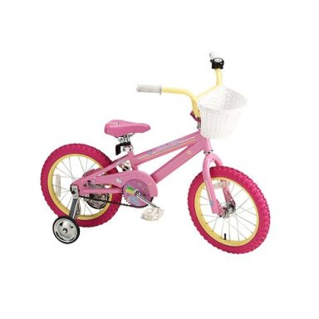
Front gear | 36 teeth
Back gear | 18 teeth
Seat height | 18 inches
Wheel circumference | 50 inches
Wheel diameter | 16 inches

New bike
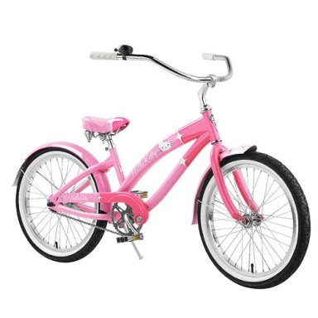
Front gear | 44 teeth
Back gear | 16 teeth
Seat height | 24 inches
Wheel circumference | 63 inches
Wheel diameter | 20 inches
The Bicycle Race

Three brothers prepare for a bicycle race. They are on the same team, so they let the others know how they are doing. Each pedals at the same recommended 90 rotations per minute, but they have different kinds of bikes and no computers. They live far apart, so there is no direct way to compare their speeds. Each bike has three gears in the front and seven in the back. Each brother has a favorite front and back gear which appears in parentheses.

Andrew
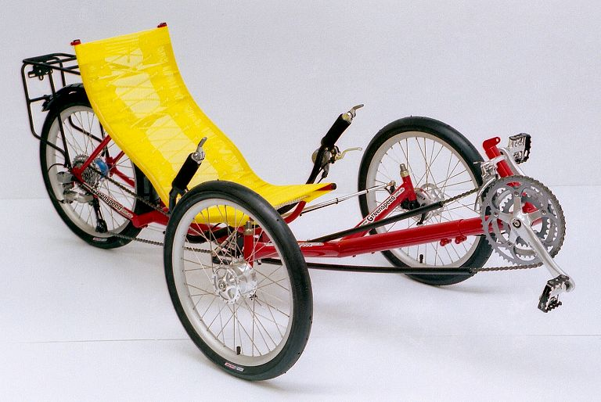
Front gears | (52), 42, 30
Back gears | 11, 12, 14, 16, (18), 21, 24
Wheel circumference | 63 inches

Brad
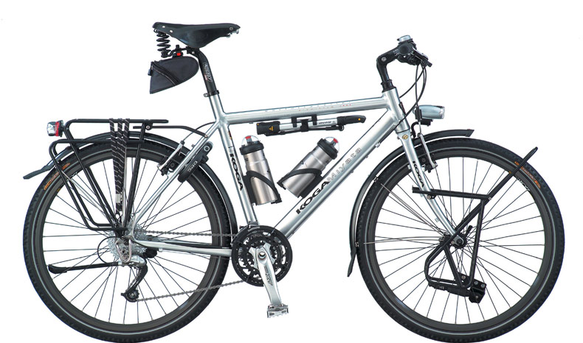
Front gears | 48, (38), 28
Back gears | 14, 16, 18, 21, (24), 28, 34
Wheel circumference | 82 inches

Dean
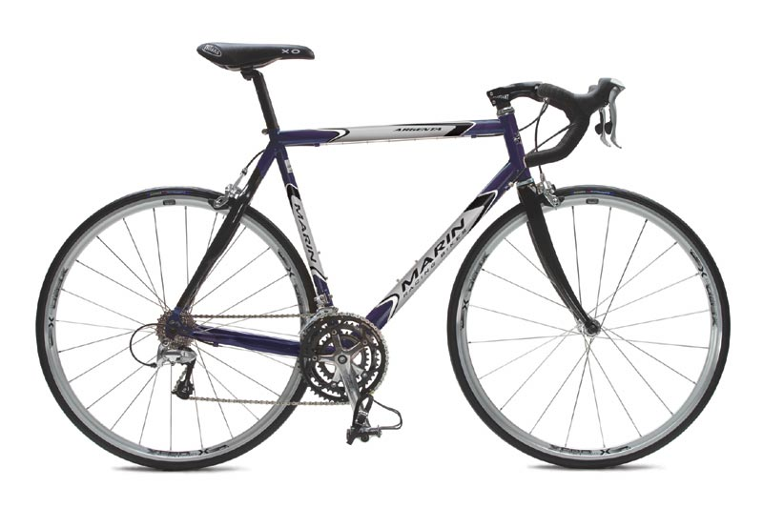
Front gears | 52, 42, (30)
Back gears | 12, 13, 14, 15, (16), 17, 21
Wheel circumference | 85 inches

The New Bicycle

1. What information do you need to calculate how far each bike goes with one turn of the pedals? Circle the right answers.

Sammi | Age | Height | Weight
Old bike | Front gear | Back gear | Seat height | Wheel circumference | Wheel diameter
New bike | Back gear | Wheel diameter | Seat height | Wheel circumference | Front gear

2. Fill the squares with the missing mathematical operations in this equation.

3. Calculate the distances for each bike. Round to two digits.

Bike | Front gear | Back gear | Gear ratio | Wheel circumference | Distance
Old
New

4. Do the distances match Sammi’s observation about the bikes?

5. Two years later Sammi’s parents are looking for Sammi’s next bicycle. If the new one is the same as the old except for the changes noted, how is the distance affected?

Change | Distance
Smaller wheel | Decrease | Increase
Bigger wheel | Decrease | Increase
Smaller front gear | Decrease | Increase
Bigger front gear | Decrease | Increase
Smaller back gear | Decrease | Increase
Bigger back gear | Decrease | Increase
Bigger wheel and bigger front gear | Decrease | Increase
Smaller wheel and bigger back gear | Decrease | Increase

The Bicycle Race

1. How many combinations of gears does each bike have? Show your calculation.

2. Using just the favorite front gears, but all of the back gears, calculate the distance one of the bikes travels with each turn of the pedals. Fill in the table below with your calculations. Round to two digits.

Example
Favorite front gear | Back gear | Gear ratio | Wheel  circumference | Distance
20 | 10 | 20 / 10 = 2.0 | 93 | 2.0 x 93 = 190

Rider: _______________
Favorite front gear | Back gear | Gear ratio | Wheel circumference | Distance

3. Your rider uses his favorite front and back gears when riding on level roads. Going uphill is difficult, so riders want to go a shorter distance with each turn of the pedals. Going downhill is easy, so riders want to go a longer distance with each turn. How should they shift gears to accomplish this? If they could change wheels, which should they choose. Circle the right answers.

 | Front gear |  | Back gear |  | Wheel
Uphill, less distance | Smaller | Bigger | Smaller | Bigger | Smaller | Bigger
Downhill, more distance | Smaller | Bigger | Smaller | Bigger | Smaller | Bigger

